**Results for Pylint on selected Projects**

Pylint

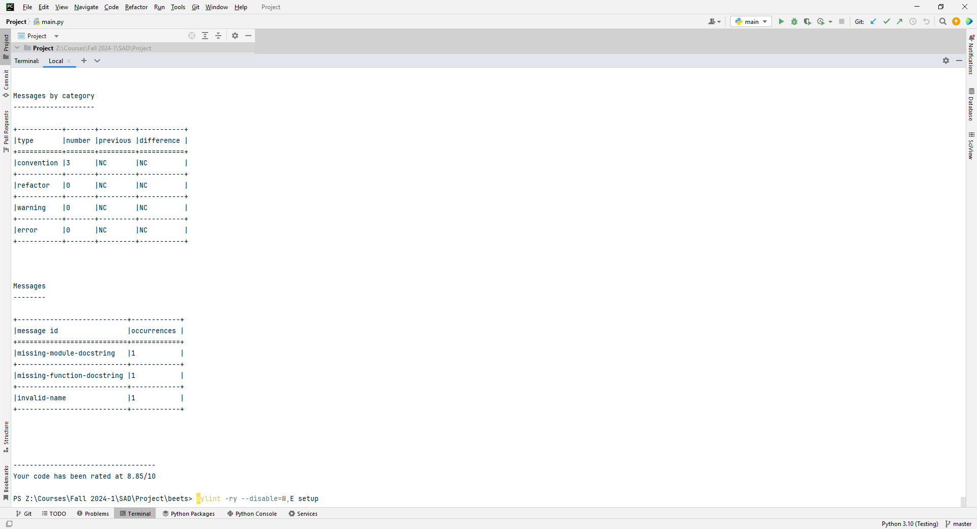

Beets Project: pylint -ry --disable=W,E setup

Report

======

26 statements analysed.

Statistics by type

------------------

+---------+-------+-----------+-----------+------------+---------+

|type |number |old number |difference |%documented |%badname |

+=========+=======+===========+===========+============+=========+

|module |1 |NC |NC |0.00 |0.00 |

+---------+-------+-----------+-----------+------------+---------+

|class |0 |NC |NC |0 |0 |

+---------+-------+-----------+-----------+------------+---------+

|method |0 |NC |NC |0 |0 |

+---------+-------+-----------+-----------+------------+---------+

|function |0 |NC |NC |0 |0 |

+---------+-------+-----------+-----------+------------+---------+

Raw metrics

-----------

+----------+-------+------+---------+-----------+

|type |number |% |previous |difference |

+==========+=======+======+=========+===========+

|code |60 |31.41 |NC |NC |

+----------+-------+------+---------+-----------+

|docstring |85 |44.50 |NC |NC |

+----------+-------+------+---------+-----------+

|comment |32 |16.75 |NC |NC |

+----------+-------+------+---------+-----------+

|empty |14 |7.33 |NC |NC |

+----------+-------+------+---------+-----------+

Duplication

-----------

+-------------------------+------+---------+-----------+

| |now |previous |difference |

+=========================+======+=========+===========+

|nb duplicated lines |0 |NC |NC |

+-------------------------+------+---------+-----------+

|percent duplicated lines |0.000 |NC |NC |

+-------------------------+------+---------+-----------+

Messages by category

--------------------

+-----------+-------+---------+-----------+

|type |number |previous |difference |

+===========+=======+=========+===========+

|convention |3 |NC |NC |

+-----------+-------+---------+-----------+

|refactor |0 |NC |NC |

+-----------+-------+---------+-----------+

|warning |0 |NC |NC |

+-----------+-------+---------+-----------+

|error |0 |NC |NC |

+-----------+-------+---------+-----------+

Messages

--------

+---------------------------+------------+

|message id |occurrences |

+===========================+============+

|missing-module-docstring |1 |

+---------------------------+------------+

|missing-function-docstring |1 |

+---------------------------+------------+

|invalid-name |1 |

+---------------------------+------------+

-----------------------------------

Your code has been rated at 8.85/10

Esptool Project: pylint -ry --disable=W,E setup

Report

======

25 statements analysed.

Statistics by type

------------------

+---------+-------+-----------+-----------+------------+---------+

|type |number |old number |difference |%documented |%badname |

+=========+=======+===========+===========+============+=========+

|module |1 |1 |= |0.00 |0.00 |

+---------+-------+-----------+-----------+------------+---------+

|class |0 |NC |NC |0 |0 |

+---------+-------+-----------+-----------+------------+---------+

|method |0 |NC |NC |0 |0 |

+---------+-------+-----------+-----------+------------+---------+

|function |0 |NC |NC |0 |0 |

+---------+-------+-----------+-----------+------------+---------+

Raw metrics

-----------

+----------+-------+------+---------+-----------+

|type |number |% |previous |difference |

+==========+=======+======+=========+===========+

|code |77 |55.40 |60 |+17.00 |

+----------+-------+------+---------+-----------+

|docstring |44 |31.65 |85 |-41.00 |

+----------+-------+------+---------+-----------+

|comment |6 |4.32 |32 |-26.00 |

+----------+-------+------+---------+-----------+

|empty |12 |8.63 |14 |-2.00 |

+----------+-------+------+---------+-----------+

Duplication

-----------

+-------------------------+------+---------+-----------+

| |now |previous |difference |

+=========================+======+=========+===========+

|nb duplicated lines |0 |0 |0 |

+-------------------------+------+---------+-----------+

|percent duplicated lines |0.000 |0.000 |= |

+-------------------------+------+---------+-----------+

Messages by category

--------------------

+-----------+-------+---------+-----------+

|type |number |previous |difference |

+===========+=======+=========+===========+

|convention |5 |3 |3 |

+-----------+-------+---------+-----------+

|refactor |0 |0 |0 |

+-----------+-------+---------+-----------+

|warning |0 |0 |0 |

+-----------+-------+---------+-----------+

|error |0 |0 |0 |

+-----------+-------+---------+-----------+

Messages

--------

+---------------------------+------------+

|message id |occurrences |

+===========================+============+

|missing-function-docstring |2 |

+---------------------------+------------+

|invalid-name |2 |

+---------------------------+------------+

|missing-module-docstring |1 |

+---------------------------+------------+

------------------------------------------------------------------

Your code has been rated at 8.00/10 (previous run: 8.85/10, -0.85)

FastPhotoStyle Project: pylint -ry --disable=W,E demo

Report

======

27 statements analysed.

Statistics by type

------------------

+---------+-------+-----------+-----------+------------+---------+

|type |number |old number |difference |%documented |%badname |

+=========+=======+===========+===========+============+=========+

|module |1 |NC |NC |100.00 |0.00 |

+---------+-------+-----------+-----------+------------+---------+

|class |0 |NC |NC |0 |0 |

+---------+-------+-----------+-----------+------------+---------+

|method |0 |NC |NC |0 |0 |

+---------+-------+-----------+-----------+------------+---------+

|function |0 |NC |NC |0 |0 |

+---------+-------+-----------+-----------+------------+---------+

Raw metrics

-----------

+----------+-------+------+---------+-----------+

|type |number |% |previous |difference |

+==========+=======+======+=========+===========+

|code |40 |80.00 |NC |NC |

+----------+-------+------+---------+-----------+

|docstring |4 |8.00 |NC |NC |

+----------+-------+------+---------+-----------+

|comment |1 |2.00 |NC |NC |

+----------+-------+------+---------+-----------+

|empty |5 |10.00 |NC |NC |

+----------+-------+------+---------+-----------+

Duplication

-----------

+-------------------------+------+---------+-----------+

| |now |previous |difference |

+=========================+======+=========+===========+

|nb duplicated lines |0 |NC |NC |

+-------------------------+------+---------+-----------+

|percent duplicated lines |0.000 |NC |NC |

+-------------------------+------+---------+-----------+

Messages by category

--------------------

+-----------+-------+---------+-----------+

|type |number |previous |difference |

+===========+=======+=========+===========+

|convention |1 |NC |NC |

+-----------+-------+---------+-----------+

|refactor |0 |NC |NC |

+-----------+-------+---------+-----------+

|warning |0 |NC |NC |

+-----------+-------+---------+-----------+

|error |0 |NC |NC |

+-----------+-------+---------+-----------+

Messages

--------

+--------------+------------+

|message id |occurrences |

+==============+============+

|line-too-long |1 |

+--------------+------------+

-----------------------------------

Your code has been rated at 9.63/10

pgcli Project: pylint -ry --disable=W,E demo

Report

======

8 statements analysed.

Statistics by type

------------------

+---------+-------+-----------+-----------+------------+---------+

|type |number |old number |difference |%documented |%badname |

+=========+=======+===========+===========+============+=========+

|module |1 |1 |= |0.00 |0.00 |

+---------+-------+-----------+-----------+------------+---------+

|class |0 |NC |NC |0 |0 |

+---------+-------+-----------+-----------+------------+---------+

|method |0 |NC |NC |0 |0 |

+---------+-------+-----------+-----------+------------+---------+

|function |0 |NC |NC |0 |0 |

+---------+-------+-----------+-----------+------------+---------+

External dependencies

---------------------

::

pgcli (setup)

Raw metrics

-----------

+----------+-------+------+---------+-----------+

|type |number |% |previous |difference |

+==========+=======+======+=========+===========+

|code |34 |45.95 |77 |-43.00 |

+----------+-------+------+---------+-----------+

|docstring |27 |36.49 |44 |-17.00 |

+----------+-------+------+---------+-----------+

|comment |6 |8.11 |6 |= |

+----------+-------+------+---------+-----------+

|empty |7 |9.46 |12 |-5.00 |

+----------+-------+------+---------+-----------+

Duplication

-----------

+-------------------------+------+---------+-----------+

| |now |previous |difference |

+=========================+======+=========+===========+

|nb duplicated lines |0 |0 |0 |

+-------------------------+------+---------+-----------+

|percent duplicated lines |0.000 |0.000 |= |

+-------------------------+------+---------+-----------+

Messages by category

--------------------

+-----------+-------+---------+-----------+

|type |number |previous |difference |

+===========+=======+=========+===========+

|convention |0 |5 |5 |

+-----------+-------+---------+-----------+

|refactor |1 |0 |0 |

+-----------+-------+---------+-----------+

|warning |0 |0 |0 |

+-----------+-------+---------+-----------+

|error |0 |0 |0 |

+-----------+-------+---------+-----------+

Messages

--------

+--------------------+------------+

|message id |occurrences |

+====================+============+

|consider-using-with |1 |

+--------------------+------------+

------------------------------------------------------------------

Your code has been rated at 8.75/10 (previous run: 8.00/10, +0.75)